Chapter 5, Solution 62.

Let v₁ = output of the first op amp
v₂ = output of the second op amp

The first stage is a summer

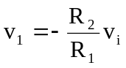 – 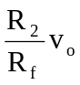 (1)

The second stage is a follower. By voltage division

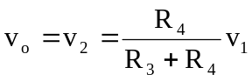 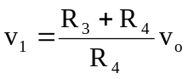 (2)

From (1) and (2),

